**TRIGER 2 (keluar pukul 08.45 wib)**

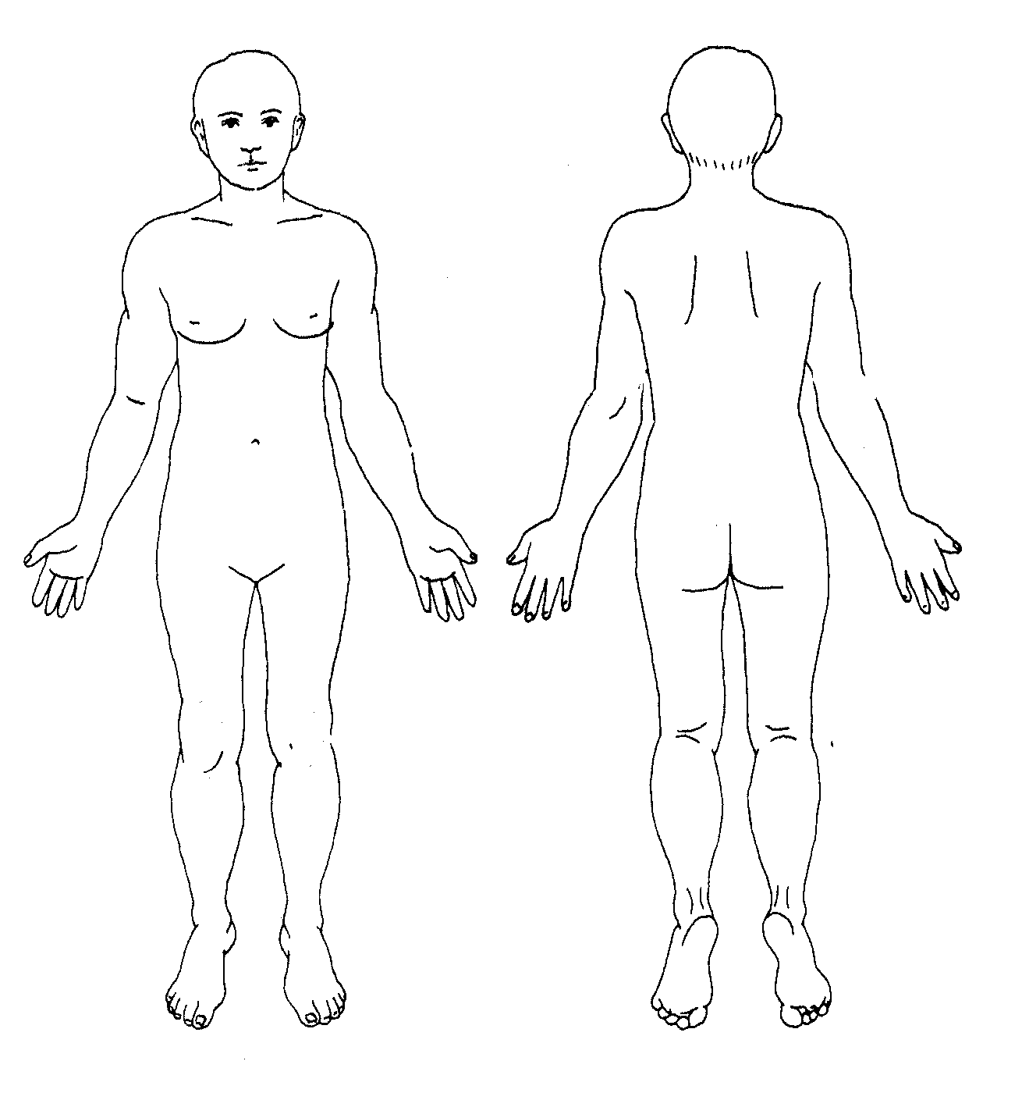

1. **PEMERIKSAAN FISIK**

Keadaan Umum : Baik, Compos Mentis.

Vital Sign

TD : -

N : 76x/menit

RR : 20 x/menit

Suhu : 36,5 0C

Pemeriksaan Dermatologi

Pada leher belakang, punggung, tangan dan tungkai ditemukan lesi patch dan plak eritem, batas tidak tegas, dengan skuama, ekskoriasi, multiple, tersebar.

