**LEMBAR KERJA PRAKTIKUM PARASITOLOGI**

**BLOK 14 (SENSORI)**

**PRODI KEDOKTERAN**



NAMA : ...........................................

NIM : ...........................................

KELOMPOK : ...........................................

**FAKULTAS KEDOKTERAN DAN ILMU KESEHATAN**

**UNIVERSITAS MUHAMMADIYAH YOGYAKARTA**

**2020/2021**

**Nama :**

**NIM : Tanda Tangan: ............................**

**1.a. EKTOPARASIT**

***Sarcoptes scabiei***

|  |  |
| --- | --- |
| **Keterangan** |  |
| Bentuk tubuh: ................   1. ...................... 2. ...................... 3. ...................... 4. ...................... 5. …………….. 6. …………….. 7. ……………... | Parasitic Insects, Mites and Ticks: Genera of Medical and Veterinary  Importance/Burrowing mites - Wikibooks, open books for an open world  **♀**  **C:\Users\umy\Downloads\PG0K6B.jpg**  3 |

***Pediculus humanus***

|  |  |
| --- | --- |
| **Keterangan** |  |
| Bentuk tubuh: ................   1. ...................... 2. ...................... 3. ...................... 4. ...................... 5. ...................... 6. ...................... 7. ……………… |  |

***Pthirus pubis***

|  |  |
| --- | --- |
| **Keterangan** | **Betina** |
| Bentuk tubuh: ................   1. ...................... 2. ...................... 3. ...................... 4. ...................... 5. ...................... 6. ...................... 7. ..................... | **D:\ADMIN BIOMEDIK & JMM\TOSHIBA (K)\biomedis\Laboran\human_lice01.jpg** |

**1.b. Hook Worm Penyebab Cutaneous Larva Migran**

Rongga Mulut Non Human Hook Worm

|  |  |  |
| --- | --- | --- |
| *A. caninum* | *A. braziliense* | *A. ceylanicum* |
| Ciri menonjol: 3 pasang gigi ventral | Ciri menonjol: 2 pasang gigi ventral berbentuk khas | Ciri menonjol: 2 pasang gigi ventral berbentuk khas |

**1.c. Lalat Penyebab Myiasis**

Familia Calliphoridae

|  |  |
| --- | --- |
| Keterangan | Lalat Dewasa |
| *Chrysomya*   * Warna hijau metalik * Bristle di dorsal thorax * Sayap jernih, venasi ke-3 dan ke-4 terpisah * Abdomen dengan garis tranversal | Tubuh: |
| *Sarcophaga*   * Warna buram * Gambaran ‘checkerboard’ di abdomen * 3 garis hitam longitudinal di dorsal thorax * Venasi sayap: vena ke-4 membentuk sudut lancip | Tubuh: |

Familia Muscidae

|  |  |
| --- | --- |
| Keterangan | Dewasa |
| *Musca domestica*   * Warna abu-abu * 4 garis longitudinal di dorsal thoraks * Sayap jernih, ujung venasi ke-3 dan ke-4 bertemu * Abdomen berwarna kuning * Tipe mulut sponging | Tubuh: |

**TTD Asisten Praktikum**

**( .................................... )**

**Nama :**

**NIM : Tanda Tangan: ............................**

**2. SERANGGA PENYEBAB GANGGUAN KULIT**

**Ordo Siphonaptera**

**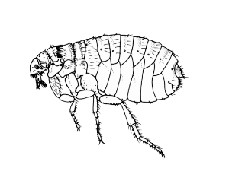**

Warna : ...................................................... Sayap: ............................... pasang

Jumlah kaki ..................................................... Tipe alat mulut .............................................

Tipe kaki : ....................................................... Tipe antena ...................................................

Spesies: ………………………..

Peran dalam Kedokteran: ……………………….

**Ordo Hemiptera**

**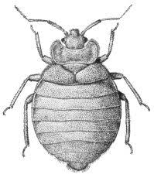**

Warna : ...................................................... Sayap: ............................... pasang

Jumlah kaki ..................................................... Tipe alat mulut .............................................

Tipe kaki : ....................................................... Tipe antena ...................................................

Spesies: ………………….

Peran dalam Kedokteran: ……………………..

**Ordo Coleoptera**

**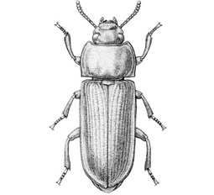**

Warna : ...................................................... Sayap: ............................... pasang

Jumlah kaki ..................................................... Tipe alat mulut .............................................

Tipe kaki : ....................................................... Tipe antena ...................................................

Spesies: ...........................

**Ordo Hymenoptera**

**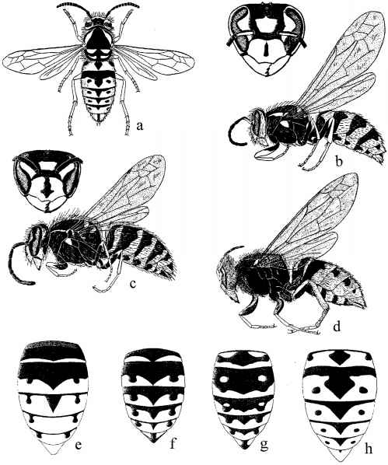**

Warna : ...................................................... Sayap: ............................... pasang

Jumlah kaki ..................................................... Tipe alat mulut .............................................

Tipe kaki : ....................................................... Tipe antena ...................................................

Spesies: ......................................

Peran dalam Kedokteran: ………………………..

**Ordo Lepidoptera**

**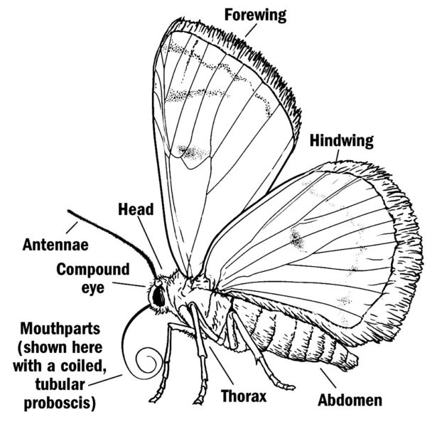**

Warna : ...................................................... Sayap: ............................... pasang

Jumlah kaki ..................................................... Tipe alat mulut .............................................

Tipe kaki : ....................................................... Tipe antena ...................................................

Spesies: ……………………….

Peran dalam Kedokteran: …………………………..

**Ordo Orthoptera**

**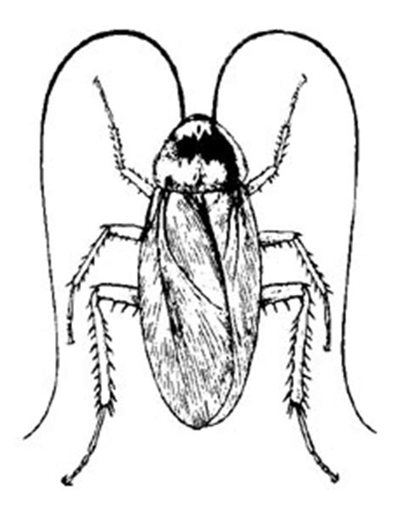**

Warna : ...................................................... Sayap: ............................... pasang

Jumlah kaki ..................................................... Tipe alat mulut .............................................

Tipe kaki : ....................................................... Tipe antena ...................................................

Spesies : .......................................................

Peran dalam Kedokteran:

**Kelas Chilopoda**

C

**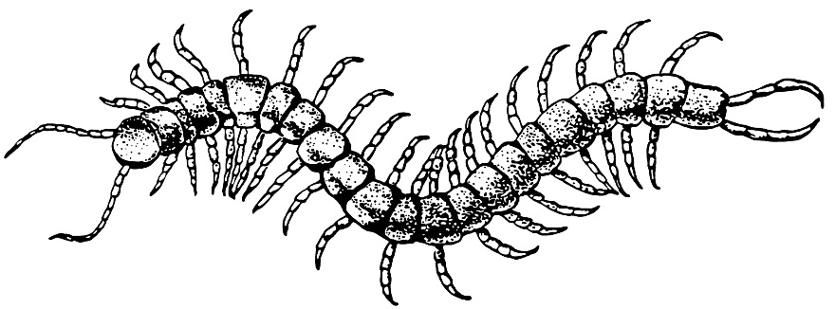**

B

A

Bentuk Tubuh : ...................................................... A : ...............................

Jumlah segmen tubuh ................................................. B : ...............................

Jumlah kaki tiap segmen : .......................................... C : ..............................

Jumlah stigma tiap segmen: .......................................................

**Kelas Diplopoda (Milipedes)**

**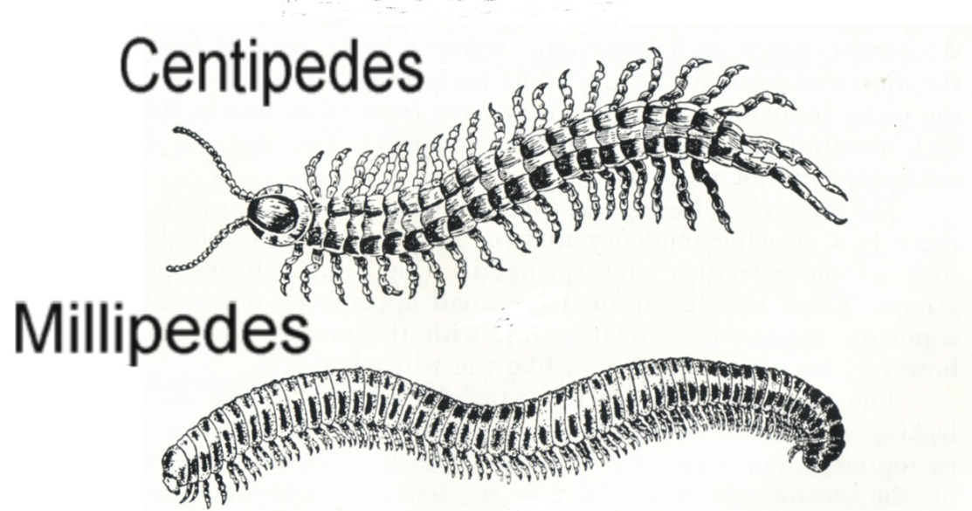**

Bentuk tubuh : .............................................. Jumlah kaki tiap segmen: .........................

Warna tubuh : .............................................. Jumlah stigma tiap segmen........................

Organ beracun : .............................................. Spesies: .....................................................

**Ordo Scorpionida**

**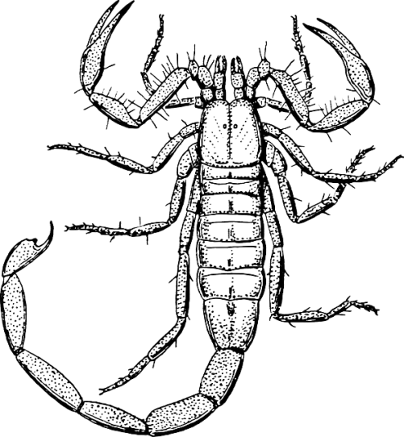**

B

C

F

E

A

D

Bentuk tubuh : .............................................. C : ........................

Organ beracun : .............................................. D : ........................

A : ...................................................................... E : .........................

B : ....................................................................... F : .........................

**TTD Asisten Praktikum**

**( .................................... )**