**PLENARY CASE**

When A 25-year-old man returned to his apartment at 5 PM in the evening, he turned on his old kerosene-fueled space heater. It had been a cold day in late spring and his third floor apartment was chilly. After spending an hour fixing dinner, he ate while watching the evening news on TV. He noticed that his vision became progressively blurred. When he got up to go to the kitchen, he felt lightheaded and unsteady. Entering the kitchen, he became very disoriented and passed out. The next thing he remembered was waking up in the intensive care unit of the hospital. Some friends who had stopped by about 7 PM had found he unconscious on the kitchen floor. They had called an ambulance, which had rushed himtextus, still unconscious, to the hospital.

An arterial blood sample drawn when he first arrived at the hospital showed the following values:

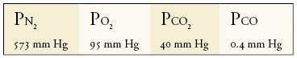

A measurement of blood reveals that the O2 content is low (50% of normal) and hemoglobin is 50% saturated with CO (50% HbCO).

The oxygen-hemoglobin saturation curve in blood (50% HbCO) and under normal conditions (2% HbCO) is shown below. CO2 binding to hemoglobin is normal in both instances.

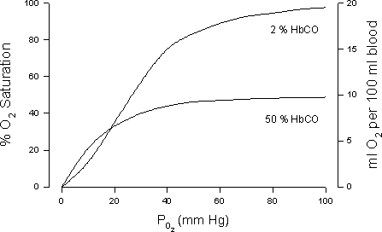

1. Discuss the case with your tutorial group and make your discussion report in English
2. The time limit collecting plenary discussion report at Wednesday, December 28th 2011
3. Plenary case report will presented at Tuesday, Januari 3th 2012, 09.00-11.00