**PRESCRIPTION WRITING**

**A. General Instructional Objectives:**

At the end of the skill lab activity, the students will be able to do prescription writing correctly

**B. Specific Instructional Objectives:**

At the end of the practicum, the students will be able to:

1. Differentiate components of a medical prescription

1. Use Latin abbreviations for prescription writing correctly

3. Use approximate weight and measure equivalents correctly

1. Write correct prescriptions based on the scenarios of different cases

**INTRODUCTION**

**MEDICAL PRESCRIPTION**

A **medical prescription** (℞) is an order (often in written form) by a qualified health care professional to a pharmacist or other therapist for a treatment to be provided to their patient. A prescription is a legal document which not only instructs in the preparation and provision of the medicine or device but indicates that the prescriber takes responsibility for the clinical care of the patient and the outcomes that may or may not be achieved.

The prescription is one of the most important therapeutic transactions between physician and patient. The art of prescription writing is an ancient inheritance. Its origin is lost in antiquity, but its importance through the centuries has made it one of the most significant written communications of the human race. The ancients started their prescription with an appeal to the gods for its success. The ancient symbol, Rx, signifying the appeal, was established centuries ago and has been carried down to the present time.

Many ancient prescriptions were noted for their multiple ingredients and complexity of preparation. The importance of the prescription and the need for complete understanding and accuracy made it imperative that a universal and standard language be employed. Thus, Latin was adopted, and its use was continued until approximately a generation ago. Present-day prescription practices lead, for the most part, to prescriptions containing a single ingredient, written in English, with doses given in the metric system. The ancient “Rx” and the Latin “Signatura,” abbreviated as “Sig.,” are all that remain of the ancient art of the prescription.

To avoid undesirable and/or serious effects on the patient, both physician and pharmacist must render the highest of professional services. Accurate diagnosis; proper selection of medication, dosage form and route of administration; proper size and timing of dose; precise dispensing; accurate labeling; and correct packaging all must be provided.

**FORM OF THE WRITTEN PRESCRIPTION**

A prescription, stripped to its barest form, consists of the superscription, the inscription, the subscription, the signa, and the name of the prescriber – written within the confines of a form.

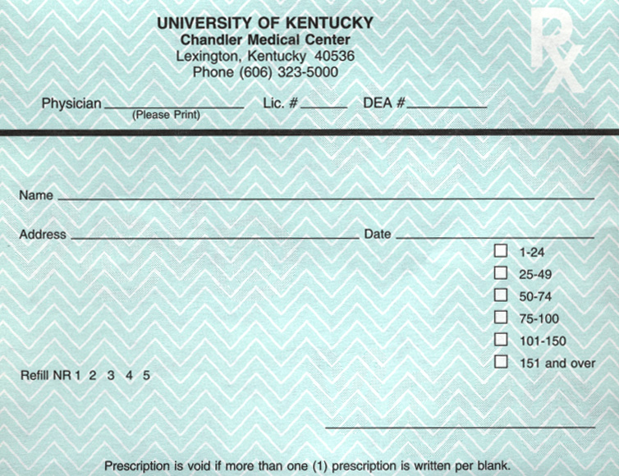

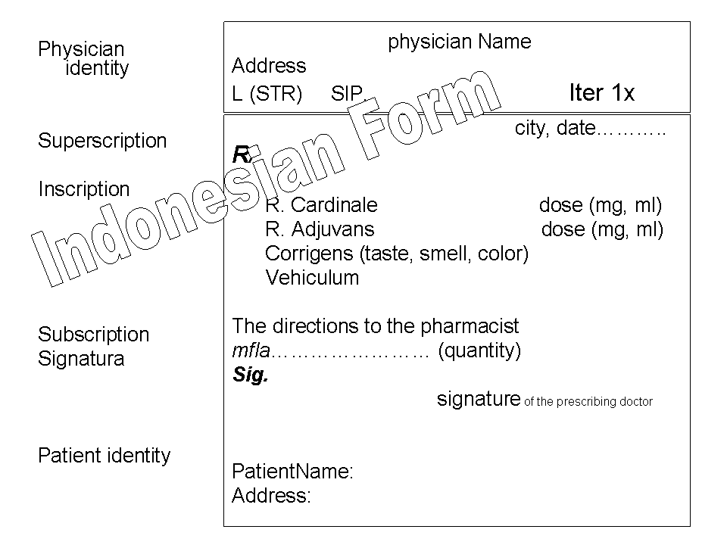

**Superscription**

The date when the prescription order is written; the name, address and age of the patient (in Indonesia the name, address and age of patient are written below enturee); and the symbol Rx (an abbreviation for “recipe,” or literally the imperative “take”). This is an exhortation to the pharmacist by the doctor, “I want the patient to have the following medication” – in other words, “take the following components and compound this medication for the patient.”

**Inscription**

The body of the prescription, containing the name and amount or strength of each ingredient. The inscription section defines what is the medication. The inscription section is further composed of one or more of:

* *Remidium Cardinale* : a “basis” or chief ingredient indended to cure (*curare*)
* *Remidium Adjuvant* : an “adjuvant” to assist its action and make it cure quickl (*cito*)
* *Remidium Corrigen*: a “corrective” to prevent or lessen any undesirable effect(*tuto*)
* A “vehicle” or “excipient” to make it suitable for administration and pleasant to the patient (*jucunde*)

**Subscription**

The “subscription” section contains dispensing directions to the pharmacist. This may be compounding instructions or quantities.

The directions to the pharmacist, usually consisting of a short sentence such as: “make a solution,” “mix and place into 10 capsules,” or “dispense 10 tablets.”

**Signatura**

The “signature” section contains directions to the patient and is often abbreviated “Sig.” or “Signa.” It also obviously contains the signature of the prescribing doctor though the word “signature” has two distinct meanings here and the abbreviations are sometimes used to avoid confusion.

From the Latin “signa,” meaning “write,” “make,” or “label,” this sections contains the directions to the patient. These should always be written in English; however, physicians continue to insert Latin abbreviations, e.g. “1 cap t.i.d. pc,” which the pharmacist translates into English, “take one capsule three times daily after meals.” Since the pharmacist always writes the label in English, the use of such abbreviations or symbols should be discouraged.

The instruction, “take as directed,” is not satisfactory and should be avoided. The directions to the patient should include a reminder of the intended purpose of the medication by including such phrases as “for pain,” “for relief of headache,” or “to relieve itching” (Table 1).

**Labeling**

When the physician wants his patient to know the name of the drug, the box on the prescription form marked “label” should be checked.

**Refills**

The physician should designate the number of refills he wishes the patient to have.

**CONVENTIONS FOR AVOIDING AMBIGUITY**

Over the years, prescribers have developed many conventions for prescription-writing, with the goal of avoiding ambiguities or misinterpretation. These include:

1. Careful use of decimal points to avoid ambiguity:
   * Avoiding unnecessary decimal points: a prescription will be written as 5 Ml instead of 5.0 Ml to avoid possible misinterpretation of 5.0 as 50.
   * Always using zero prefix decimals: e.g. 0.5 instead of .5 to avoid misinterpretation of .5 as 5.
   * Avoiding trailing zeros on decimals: e.g. 0.5 instead of .50 to avoid misinterpretation of .50 as 50.
   * Avoiding decimals altogether by changing the units: 0.5 g is less easily confused when written as 500 mg.
2. “Ml” is used instead of “cc” or “cm³” even though they are technically equivalent
3. Directions written out in full in English/ Indonesia (although some common Latin abbreviations are listed below).
4. Quantities given directly or implied by the frequency and duration of the directions.
5. Where the directions are “as needed”, the quantity should always be specified.
6. Where possible, usage directions should specify times (7 am, 3 pm, 11 pm) rather than simply frequency (3 times a day) and especially relationship to meals for orally consumed medication.
7. The use of permanent ink.
8. Avoiding unspecified *prn* or “as needed” instructions—instead, specific limits and indicators are provided e.g. “every 3 hours prn pain”.
9. For refills, the minimum duration between repeats and number of repeats should be specified.
10. Providing the indication for all prescriptions even when obvious to the prescriber, so that the pharmacist may identify possible errors.
11. Avoiding non-standardized units such as “teaspoons” or “tablespoons”.
12. Writing out numbers as words *and* numerals (“dispense #30 (thirty)”) as in a bank draft or cheque.

**PROPRIETARY VS NON-PROPRIETARY (GENERIC) PRESCRIPTIONS**

In recent years, some hospitals and private physicians are indicating on the prescription their willingness or desire that the pharmacist dispense a non-proprietary or “generic-named” preparation instead of the trade name item written on the prescription. Some have a box on the prescription designated “N.P.P.” In this way, the pharmacist can use a form of the drug which may be less expensive to the patient.

The amount to be dispensed should be clearly stated and should be that needed by the patient. Excessive amounts should never be dispensed, as it is not only expensive to the patient, but may lead to accumulation of medicines in the home, which can later cause harm to the patient or members of his family. It is far better to have several refills of a prescription than to have an excessive amount prescribed at one time (Table 2).

**Latin Abbreviations and Approximate Weight & Measure Equivalents**

**for Prescription Writing**

**Table 1. Latin Abbreviations**

|  |  |  |
| --- | --- | --- |
| **Partial list of prescription abbreviations** | | |
| **Abbreviation** | **Latin** | **Meaning** |
| Aa | Ana | of each |
| Ad | Ad | to,up to |
| a.c. | Ante cibum | before meals |
| a.d. | aurio dextra | right ear |
| ad lib. | Ad libitum | use as much as one desires; freely; at pleasure |
| admov. | Admove | Apply |
| Agit | Agita | stir/shake |
| alt. h. | Alternis horis | every other hour |
| a.m. | Ante Meridiem | morning, before noon |
| Amp |  | Ampule |
| Amt |  | Amount |
| Aq | Aqua | Water |
| a.l., a.s. | aurio laeva, aurio sinister | left ear |
| A.T.C. |  | around the clock |
| a.u. | auris utrae | both ears |
| Bis | Bis | Twice |
| b.i.d. | bis in die | twice daily |
| B.M. |  | bowel movement |
| bol. | Bolus | as a large single dose (usually intravenously) |
| B.S. |  | blood sugar |
| B.S.A |  | body surface areas |
| BUCC |  | inside cheek |
| Cap., caps. | Capsula | Capsule |
| C | Cum | with (usually written with a bar on top of the “c”) |
| C | Cibos | Food |
| Cc | Cum cibos | with food, (but also cubic centimeter) |
| Cf |  | with food |
| Collyr | Collyrium | eye lotion |
| comp. |  | Compound |
| cr., crm |  | Cream |
| Cum aq | Cum aqua | with water |
| D5W |  | dextrose 5% solution (sometimes written as D5W) |
| D5NS |  | dextrose 5% in normal saline (0.9%) |
| D.A.W. |  | dispense as written |
| dc, D/C, disc |  | Discontinue |
| Dieb. Alt. | diebus alternis | every other day |
| dil. |  | Dilute |

|  |  |  |  |  |  |
| --- | --- | --- | --- | --- | --- |
| **Partial list of prescription abbreviations** | | | | | |
| **Abbreviation** | | **Latin** | | | **Meaning** |
| Disp. |  | | | Dispense | |
| div. |  | | | Divide | |
| d.t.d. | enture tales doses | | | give of such doses | |
| D.W. |  | | | distilled water | |
| Elix. |  | | | Elixir | |
| e.m.p. | ex modo prescripto | | | As directed | |
| emuls. | Emulsum | | | Emulsion | |
| Et | Et | | | And | |
| ex aq | ex aqua | | | In water | |
| fl., fld. |  | | | Fluid | |
| ft. | Fiat | | | make; let it be made | |
| G |  | | | Gram | |
| Gr |  | | | Grain | |
| gtt(s) | Gutta(e) | | | drop(s) | |
| H |  | | | Hypodermic | |
| h, hr | Hora | | | Hour | |
| h.s. | hora somni | | | At bedtime | |
| ID |  | | | Intradermal | |
| IM |  | | | intramuscular (with respect to injections) | |
| inj. | Injection | | | Injection | |
| in vit. | In vitro | | | in glass | |
| IP |  | | | Intraperitoneal | |
| IV |  | | | Intravenous | |
| IVP |  | | | intravenous push | |
| IVPB |  | | | intravenous piggyback | |
| L.A.S. |  | | | label as such | |
| LCD |  | | | coal tar solution | |
| Lin | Linimentum | | | Liniment | |
| Liq | Liquor | | | Solution | |
| lot. |  | | | Lotion | |
| m. | Misce | | | Mix | |
| M, min | Minimum | | | a minimum | |
| Mcg |  | | | Microgram | |
| Meq |  | | | Milliequivalent | |
| Mg |  | | | Milligram | |
| mist. | Mistura | | | Mix | |
| Mitte | Mitte | | | Send | |
| Ml |  | | | Milliliter | |
| Nebul | Nebula | | | a spray | |
| **Partial list of prescription abbreviations** | | | | | |
| **Abbreviation** | | | **Latin** | | **Meaning** |
| N.M.T. |  | | | not more than | |
| noct. | Nocte | | | at night | |
| Non rep. | non repetatur | | | no repeats | |
| NS |  | | | normal saline (0.9%) | |
| ½NS |  | | | half normal saline (0.45%) | |
| N.T.E. |  | | | not to exceed | |
| O_2 |  | | | both eyes, sometimes written as o2 | |
| o.d. | oculus dexter | | | right eye | |
| o.m. | Omni mane | | | every morning | |
| o.n. | Omni nocte | | | every night | |
| o.s. | oculus sinister | | | left eye | |
| o.u. | oculus uterque | | | both eyes | |
| Oz |  | | | Ounce | |
| Per | Per | | | by or through | |
| p.c. | post cibum | | | after meals | |
| p.m. | Post Meridiem | | | evening or afternoon | |
| Prn | pro re nata | | | as needed | |
| p.o. | per os | | | by mouth or orally | |
| Placebo | Placebo | | | to please | |
| p.r. |  | | | by rectum | |
| pulv. | Pulvis | | | Powder | |
| Q | Quaque | | | Every | |
| q.a.d. | quoque alternis die | | | every other day | |
| q.a.m. | quaque die ante meridiem | | | every day before noon | |
| q.p.m. |  | | | every day after noon | |
| q.h. | quaque hora | | | every hour | |
| q.h.s. | quaque hora somni | | | every night at bedtime | |
| q.1h | quaque 1 hora | | | every 1 hour; (can replace “1” with other numbers) | |
| q.d. | quaque die | | | every day | |
| q.i.d. | I in die | | | four times a day | |
| q.o.d. |  | | | every other day | |
| Qqh | I quaque hora | | | every four hours | |
| q.s. | quantum sufficiat | | | a sufficient quantity | |
| QWK |  | | | every week | |
| R |  | | | Rectal | |
| rep., rept. | Repetatur | | | Repeats | |
| RL, R/L |  | | | Ringer’s lactate | |

|  |  |  |  |  |
| --- | --- | --- | --- | --- |
| **Partial list of prescription abbreviations** | | | | |
| **Abbreviation** | | **Latin** | | **Meaning** |
| S | Sine | | without (usually written with a bar on top of the “s”) | |
| s.a. | secundum artum | | use your judgement | |
| SC, subc, subcut, subq, SQ |  | | Subcutaneous | |
| Sig |  | | write on label | |
| SL |  | | sublingually, under the tongue | |
| Sol | Solution | | Solution | |
| s.o.s., si op. Sit | si opus sit | | if there is a need | |
| Ss | Semis | | one half | |
| s,s | Sine | | Without | |
| Stat | Statim | | Immediately | |
| Supp | Suppositorium | | Suppository | |
| Susp |  | | Suspension | |
| Syr | Syrupus | | Syrup | |
| Tab | Tabella | | Tablet | |
| tal., t | Talus | | Such | |
| Tbsp |  | | Tablespoon | |
| Troche | Trochiscus | | Lozenge | |
| Tsp |  | | Teaspoon | |
| t.i.d. | ter in die | | three times a day | |
| t.d.s. | ter die sumendum | | three times a day | |
| t.i.w. |  | | three times a week | |
| top. |  | | Topical | |
| T.P.N. |  | | total parenteral nutrition | |
| tr, tinc., tinct. |  | | Tincture | |
| Troch | trochicus, trochici | | lozenge, lozenges | |
| u.d., ut. Dict. | Ut dictum | | as directed | |
| ungt. | Unguentum | | Ointment | |
| Vag |  | | Vaginally | |
| W |  | | With | |
| w/o |  | | Without | |
| X |  | | Times | |
| Y.O. |  | | years old | |

To avoid ambiguity, the following abbreviations are not recommended:

* **a.u., a.s., a.d.** – Latin for both, left and right ears; the “a” can be misread to be an “o” and interpreted to mean both, right or left eyes
* **d/c** – can mean “discontinue” or “discharge”
* **h.s.** – can mean half strength or “hour of sleep”
* **q.d.** – meant “every day” but the “.” after the “q” is interpreted to be an “I” thus “q.i.d.” or quadrupling the dose to 4 times a day
* **q.o.d.** – meant “every other day” but the “o” can be interpreted as “.” or “I” resulting in double or eight times the frequency
* **SC/SQ** – meant “subcutaneaous” but mistaken for “SL” for “sublingual”
* **T.I.W** – meant 3 times a week but mistaken for twice a week
* **U** – meant “units” but mistaken for “0”, “4” or “cc” when poorly written; conversely **cc** can be mistaken for “U”
* **μg** – meant “microgram” but mistaken for “mg”; this 1000-fold error can cause potentially fatal misunderstandings

**Table 2. Approximate Weight and Measure Equivalents**

|  |  |  |  |
| --- | --- | --- | --- |
| **Liquid Measure** | | | |
| Metric | Approximate  Apothecary  Equivalents | Metric | Approximate  Apothecary  Equivalents |
| 1000 ml | 1 quart | 3 ml | 45 minims |
| 750 ml | 1-1/2 pints | 2 ml | 30 minims |
| 500 ml | 1 pint | 1 ml | 15 minims |
| 250 ml | 8 fluid ounces | 0.75 ml | 12 minims |
| 200 ml | 7 fluid ounces | 0.6 ml | 10 minims |
| 100 ml | 3-1/2 fluid ounces | 0.5 ml | 8 minims |
| 50 ml | 1-3/4 fluid ounces | 0.3 ml | 5 minims |
| 30 ml | 1 fluid ounce | 0.25 ml | 4 minims |
| 15 ml | 4 fluid drams | 0.2 ml | 3 minims |
| 10 ml | 2-1/2 fluid drams | 0.1 ml | 1-1/2 minims |
| 8 ml | 2 fluid drams | 0.06 ml | 1 minims |
| 5 ml | 1-1/4 fluid drams | 0.05 ml | ¾ minims |
| 4 ml | 1 fluid dram | 0.03 ml | ½ minims |

|  |  |  |  |
| --- | --- | --- | --- |
| **Weight** | | | |
| Weight | Approximate  Apothecary  Equivalents | Metric | Approximate  Apothecary  Equivalents |
| 30 Gm | 1 ounce | 30 mg | ½ grain |
| 15 Gm | 4 drams | 25 mg | 3/8 grain |
| 10 Gm | 2-1/2 drams | 20 mg | 1/3 grain |
| 7.5 Gm | 2 drams | 15 mg | ¼ grain |
| 6 Gm | 90 grains | 12 mg | 1/5 grain |
| 5 Gm | 75 grains | 10 mg | 1/6 grain |
| 4 Gm | 60 grains (1 dram) | 8 mg | 1/8 grain |
| 3 Gm | 45 grains | 6 mg | 1/10 grain |
| 2 Gm | 30 grains (1/2 dram) | 5 mg | 1/12 grain |
| 1.5 Gm | 22 grains | 4 mg | 1/15 grain |
| 1 Gm | 15 grains | 3 mg | 1/20 grain |
| 0.75 Gm | 12 grains | 2 mg | 1/30 grain |
| 0.6 Gm | 10 grains | 1.5 mg | 1/40 grain |
| 0.5 Gm | 7-1/2 grains | 1.2 mg | 1/50 grain |
| 0.4 Gm | 6 grains | 1 mg | 1/60 grain |
| 0.3 Gm | 5 grains | 0.8 mg | 1/80 grain |
| 0.25 Gm | 4 grains | 0.6 mg | 1/100 grain |
| 0.2 Gm | 3 grains | 0.5 mg | 1/120 grain |
| 0.15 Gm | 2-1/2 grains | 0.4 mg | 1/150 grain |
| 0.12 Gm | 2 grains | 0.3 mg | 1/200 grain |
| 0.1 Gm | 1-1/2 grains | 0.25 mg | 1/250 grain |
| 75 | 1-1/4 grains | 0.2 mg | 1/300 grain |
| 60 mg | 1 grain | 0.15 mg | 1/400 grain |
| 50 mg | ¾ grain | 0.12 mg | 1/500 grain |
| 40 mg | 2/3 grain | 0.1 mg | 1/600 grain |

**Assignment**

**Write appropriate prescription for each case below in the prescription form:**

* + - 1. A 3-year-old girl, 10 kg, is brought by her mother to a general practitioner complaining of watery stools. She has been having watery stools for 2 days. She has been vomiting 3 times since in the morning until being examined. On physical examination, there is no fever (temperature 36, 8o C)

Write prescription for oral rehydration and Domperidon antiemetic for the child.

Is antibiotic needed to be given? If yes, give explanation and write the prescription!

* + - 1. A 14-year-old boy, 40 kg, was brought by his parents to a general practitioner complaining of fever. He had been suffering from fever for 3 days with cold and cough. After examined by the doctor in the morning, she got prescription of Stimuno 3x1 cap/day, Primadol 3x1 tab/day, and Primperan 3x1 tab/day. In the afternoon she was brought to a hospital emergency unit because his neck and tongue got stiff after taking the medicines.

Write prescription for the medicines given by the doctor in the morning.

Is there any correlation between the prescribed medicines with the child’s symptoms resulting him to be brought to the emergency unit.

3. A 67-year-old man suffering from asthma and hypertension usually visits a community health center for medical check up. When visiting his ill granddaughter, he got an asthma attack and the medicines regularly taken are finished. His son takes him to see you in your clinic.

Write prescription for asthma: aminofilin 200 mg – methylpredisolon 4 mg – CTM 2mg – gliseril guaikolat 50 mg to be made pulvis which are placed into capsulesl to be taken 3x1 cap/day. For hypertension, write prescription for furosemid dan beta blocker.

4. A 22-year-old woman is two-month pregnant complaining of vomiting and having headache in the morning.

Write prescription for antiemetic and analgesic for the patient.

5. A 47-year-old woman, overweight, suffers from non-insulin-dependent diabetes mellitus and moderate hypertension, with mild renal function disorder.

Write prescription for oral antidiabetic to be taken once a day in the morning after meal, diuretic to be taken one a day, and ACE inhibitor 2x1 tab/day

6. A 40-year-old man suffers from bronchial asthma. The doctor prescribes him teophyllin 3x125 mg/ day. Because of being busy with his job, he often forgets to take his medicine hence he has been having asthma attacks.

Write prescription with the same medicine substance in the preparation form that will improve patient’s compliance.

7. A 10-year-old boy is complaining of having painful ear passage after being cleaned with cotton bud.

Write prescription for antibiotic and analgesic ear drops!

1. A19-year-old woman visits a general practitioner complaining of red eyes. When she woke up in the morning, her eyelids were sticky. She also has fever and headache.

Write prescription for topical medicine for eyes (instillation, cream, and ointment), and antipyretic analgesic

9. A 45-year-old man is complaining of itchy feeling in the wrist after using new watch.

Write prescription for topical medicine for skin inflammation due to contact with the watch metal.

10. A 19-year-old man is complaining of sore throat, fever and headache.

Write prescription for gargle, lozenges and antipyretic analgesic

11. A 3-year-old girl is brought by her mother to a general practitioner complaining of fever and convulsion.

Write prescription for diazepam per rectum with instruction to be given when the child has convulsion.